Ministry of Water & Energy

Geological & Geotechnical Investigation for the Prefeasibility & Feasibility Study of Dabus Hydropower Project

Terms of Reference

Addis-Ababa July 2023

F3 Bill of Quantities

ACTIVITY 1 – FIELD GEOTECHNICAL INVESTIGATIONS
Item. No | Description | Unit | Quantity | Unit price (Birr) | Amount (Birr)
1 | HPP ch – 130;General
1.1 | Mobilization and demobilization of rigs and drilling crews | L.S | 1
1.2 | inter borehole mobilization | No | 17
1.3 | Execution of temporary access tracks and temporary river crossing, including maintenance during the site activities,throughout the entire working area including that for construction materials. | L.S | 1
1.4 | Cleaning, clearing and environmental closure of the site after the end of the site activities, throughout entire working area including that for construction materials. | L.S | 1
2 | HPP ch – 130;Core Drilling
2.1 | Vertical core drilling in all geological formations with minimum core barrel diameter of 76 mm. Including temporary casing, if needed. Including water supply, power supply and all other services required
2.1.1 | Depth from 0 to 50m | m | 850
2.1.2 | Depth from 50 to 100m | m | 300
2.1.3 | Depth from 100 to 150m | m | 0
2.1.4 | Depth from 150 to 200m | m | 0
2.2 | Placing concrete benchmark on drilled boreholes | No | 17
2.3 | Wooden core box | No | 230
2.4 | Installation of piezometric pipes in selected boreholes | No | 5
3 | HPP ch – 130;Test pit
3.1 | Test pit escavation up to 5m, minimum dimensions 3x3 | No | 15
4 | HPP ch – 130;In situ tests
4.1 | Lugeon Test, with test section of 5m, executed with single of double packer | No | 107
4.2 | Lefranc Test, with test section of 5m | No | 6
4.3 | Goodman jack Dilatometer Test | No | 45
4.4 | Standard penetration test (SPT) | No | 15
4.5 | Marchetti Dilatometric Test (DMT) | No | 100
4.6 | Cone penetration test with measure of pore pressure (CPTU),up to 10 meters | m | 100
4.7 | Falling and Constant Head Tests in Test pits | No | 8

5 | HPP ch – 108;General | Unit | Quantity | Unit price (Birr) | Amount (Birr)
5.1 | Mobilization and demobilization of rigs and drilling crews | L.S | 1
5.2 | inter borehole mobilization | No | 12
5.3 | Execution of temporary access tracks and temporary river crossing, including maintenance during the site activities, Cleaning, clearing and environmental closure of the site after the end of the site activities, throughout the entire working area including that for construction materials. | L.S | 1
5.4 | Cleaning, clearing and environmental closure of the site after the end of the site activities, throughout entire working area including that for construction materials. | L.S | 1
6 | HPP ch – 108;Core Drilling
6.1 | Vertical core drilling in all geological formations with minimum core barrel diameter of 76 mm. Including temporary casing, if needed. Including water supply, power supply and all other services required
6.1.1 | Depth from 0 to 50m | m | 560
6.1.2 | Depth from 50 to 100m | m | 200
6.1.3 | Depth from 100 to 150m | m | 40
6.1.4 | Depth from 150 to 200m | m | -
6.2 | Placing concrete benchmark on drilled boreholes | No | 12
6.3 | Wooden core box | No | 160
6.4 | Installation of piezometric pipes in selected boreholes | No | 5
7 | HPP ch – 108; Test pits
7.1 | Trenches escavation up to 5m, minimum dimensions 3x3 | No | 2
8 | HPP ch – 108;In situ tests
8.1 | Lugeon Test, with test section of 5m, executed with single or double packer | No | 53
8.2 | Goodman jack Dilatometer Test | No | 27
8.3 | Marchetti Dilatometric Test (DMT) | No | 20
8.4 | Cone penetration test with measure of pore pressure (CPTU),up to 10 meters | No | 20
 | Sub-Total ACTIVITY 1 (Birr)

ACTIVITY – 2 GEOPHYSICAL INVESTIGATIONS
Item. No | Description | Unit | Quantity | Unit price (Birr) | Amount (Birr)
9 | Seismic refraction
9.1 | Seismic refraction for the HPP ch-130 | m | 11880
9.2 | Seismic refraction for the HPP ch-108 | m | 2880
9.3 | Cost of explosive and related accessesories  detonators, cost of storage, handling transportation and security guard including explosive expert | L.S
 | Sub-Total ACTIVIT -2 (Birr)
ACTIVITY 3 – LABORATORY TESTS
Item. No | Description | Unit | Quantity | Unit price (Birr) | Amount (Birr)
10 | HPP ch -130 –Laboratory test on rock samples
10.1 | Unit weight | No | 30
10.2 | Petrographic analysis on thin section | No | 15
10.3 | Point load | No | 30
10.4 | UCS | No | 30
10.5 | Trilaxial compressive test | No | 30
10.6 | Brazilian test | No | 15
10.7 | Sheaf Strength test | No | 15
10.8 | Sonic velocity | No | 20
11 | HPP ch-130 - Laboratory test on soil samples
11.1 | Grain size distribution | No | 20
11.2 | Moisture Content | No | 20
11.3 | Unit weight | No | 20
11.4 | Atterberg limits | No | 20
11.5 | Permeability Test | No | 20
11.6 | Unconfined compressive strength | No | 9
11.7 | Unconsolidated-undrained triaxial compression on soils | No | 1
11.8 | Consolidated-undrained triaxial compression on soils | No | 1
11.9 | Consolidated-drained triaxial compression on soils | No | 5
11.10 | Direct shear of soils under consolidated drained conditions | No | 5
11.11 | Consolidation. | No | 9

 |  | Unit | Quantity | Unit price (Birr) | Amount (Birr)
12 | HPP ch -108–Laboratory test on rock samples
12.1 | Unit weight | No | 20
12.2 | Petrographic analysis on thin section | No | 10
12.3 | Point load | No | 15
12.4 | UCS | No | 30
12.5 | Trilaxial compressive test | No | 30
12.6 | Brazilian test | No | 15
12.7 | Sheaf Strength test | No | 10
12.8 | Sonic velocity | No | 15
13 | HPP ch-108 - Laboratory test on soil samples
13.1 | Grain size distribution | No | 10
13.2 | Moisture Content | No | 10
13.3 | Unit weight | No | 20
13.4 | Atterberg limits | No | 10
13.5 | Unconfined compressive strength | No | 3
13.6 | Consolidated-drained triaxial compression on soils | No | 3
13.7 | Direct shear of soils under consolidated drained conditions | No | 3
13.8 | Consolidation. |  | 3
14 | Laboratory test on water samples
14.1 | Physico –chemical analysis | No | 6
15 | Specimen collection for rock material, loose material and water samples | L.S | 1
 | Sub-Total ACTIVITY 3 (Birr)
ACTIVITY 4 –CONSTUCTION MATERIAL INVESTIGATION
Item. No | Description | Unit | Quantity | Unit price  (Birr) | Amount (Birr)
16 | General
16.1 | inter borehole mobilization | No | 1
17 | Core Drilling
17.1 | Vertical core drilling in all geological formations with minimum core barrel diameter of 76 mm. Including temporary casing, if needed.
17.1.1 | Depth from 0 to 50m | m | 80
17.1.2 | Depth from 50 to 100m | m | -
17.1.3 | Depth from 100 to 150m | m | -
17.1.4 | Depth from 150 to 200m | m | -
17.1.5 | Wooden core box | No | 16

18 | Seismic refraction
18.1 | Seismic refraction |  | m |  | 960
19 | Laboratory test on rock samples
19.1 | Unit weight |  | No |  | 10
19.2 | Petrographic analysis on thin section |  | No |  | 10
19.3 | Point load |  | No |  | 10
19.4 | Los Angeles test |  | No |  | 10
19.5 | Alkali-silica reaction |  |  |  | 10
19.6 | Determination of sulphate content |  | No |  | 10
19.7 | Determination of chloride content |  | No |  | 10
20 | Specimen collection for rock material, loose material and water samples |  | L.S |  | 1
 | Sub-Total ACTIVITY 4 (Birr)
ACTIVITY 5- CORE SORE
Item. No | Description | Unit |  | Quantity |  | Unit price (Birr) |  | Amount (Birr)
21 | Construction of a core store to store core boxes and other material from the geotechnical Investigations. | L.s |  | 1
 | Sub-Total ACTIVITY 5 (Birr)
ACTIVITY 6- PREPAREATION OF DELIVERABLES
Item. No | Description |  | Unit |  | Quantity |  | Unit price (Birr) | Amount (Birr)
 | Monthly Report
22 | Preparation of Draft Report on boreholes in the DAM AREA & WATERWAYS AND PH AERA for the HPP ch-130. Including 3 hardcopies and 3 softcopies for the separately for the Dam & Water ways. |  | L.s |  | 1
23 | Preparation of Draft Report on boreholes in the DAM AREA & WATERWAYS AND PH AERA for the HPP ch-108. Including 3 hardcopies and 3 softcopies separately for the Dam & Water ways. |  | L.s |  | 1
24 | Preparation of Draft Report of the geophysical investigation for the HPP ch – 108 & HPP ch – 130 including 3 hardcopies and 3 softcopies separately foreach site. |  | L.s |  | 1
25 | Preparation of the final Report of the complete Geotechnical investigation. Including 3 hardcopies and 3 softcopies. |  | L.s |  | 1
 | Sub-Total ACTIVITY 6 (Birr))
 | Sub Total (ACTIVITES 1+2+3+4+5+6)
 | TOTAL

PART 1 TERMS OF REFERENCE

INDEX
Paragraph Subject Page

1 CONTENTS i
2 PROJECT OVERVIEW i
3 LOCATION and ACCESS ROAD v
4 DEFINITION of TERMS viii
5 SCOPE of SERVICES x
5.1 Field Investigations x
5.1.1 Boreholes xi
5.1.2 Pits xii
5.1.3 In situ tests xiii
5.2 Geophysical investigations xv
5.3 Laboratory Tests xvii
5.4 Construction Material Investigations xix
5.4.1 Boreholes xix
5.4.2 Geophysical investigations xix
5.4.3 Laboratory tests xx
5.5 Core Store xx
5.6 Preparation of deliverables xxi
6 DURATION OF SERVICES xxiii
7 KEY STAFF xxiv
8 DELIVERABLES, MEETING and SCHEDULE xxv
9 PAYMENT SCHEDULE xxvi

Annexes
- Annex A: Drawings
- Annex B: Bill of Quantities
- Annex C: Technical Specifications

- CONTENTS
In the following the Terms of Reference (ToR) of the geological and geotechnical investigations for the Pre-Feasibility and Feasibility Study of the Dabus Hydropower Project are illustrated.
This document comprises the following sections:
PROJECT OVERVIEW;
LOCATIONS and ACCESS ROADS;
DEFINITIONS of TERMS;
SCOPE of SERVICES
DURATION OF THE SERVICES
KEY STAFF
DELIVERABLES MEETING and SCHEDULE
PAYMENT SCHEDULE
No 3 annexes complete the report.
- PROJECT OVERVIEW
The Dabus project foreseen two power plants in cascade along the Dabus River, named:
- HPP ch -130
- HPP ch -108
The first plant, HPP ch-130, foreseen:
- RCC dam
  - 55 m maximum height
  - 1.6 km length
- Headrace Tunnel
  - 5.5 km length
  - 9.0 m diameter
- Surge shaft
  - 79 m height
  - 16 m diameter
- Penstock
  - 2.1 km length
  - 7 m diameter
  - 2 # number
- Powerhouse
  - Open air, equipped with N°2 Francis turbines
  - 45x85 m size
The second plant, HPP ch-108, foreseen:
- RCC dam
  - 82 m maximum height
  - 444 m length
- Headrace Tunnel
  - 6.2 km length
  - 9.0 m diameter
- Surge shaft
  - 73 m height
  - 16 m diameter
- Penstock
  - 970 m length
  - 5 m diameter
  - 2 # number
- Powerhouse
  - Open air, equipped with N°2 Francis turbines
  - 45x85 m size
The following drawing shows the general plan of the Dabus HPPs project

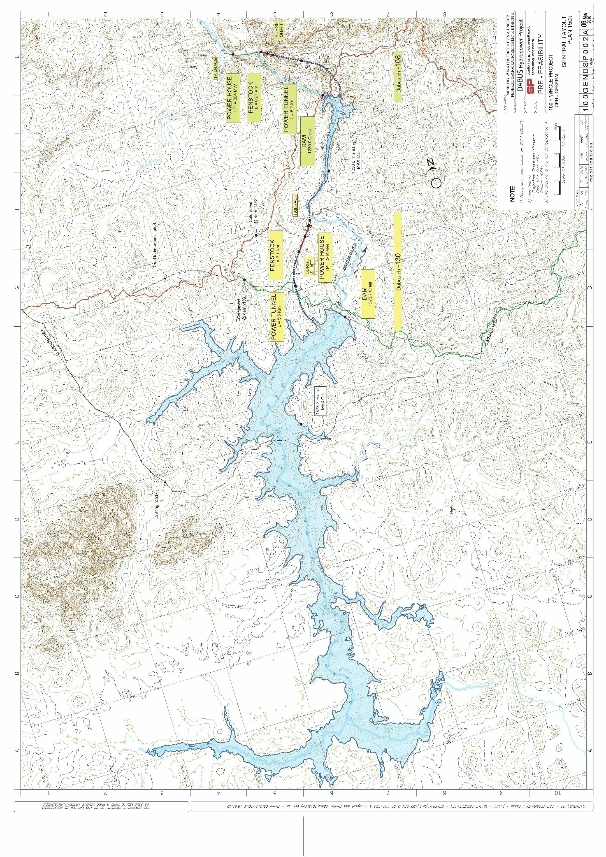
Figure 2.1: General layout

The accessibility of the sites is shown in the drawing “230INVDSP001, Roads” and detailed in the next chapter.
In addition, since being necessary to cross the river to perform the geological and geotechnical investigations on the left bank of the river for the HPP ch -108, the distribution of the monthly flow average hydrologic year is given in the following figure:

Figure 2.2: Dabus, DAM CH-108, average year monthly flow.

- LOCATION and ACCESS ROAD
The Dabus cascade project area is located in Western Ethiopia in the Oromya and Benshangul Gumuz Regions approximately 50 km SE from the city of Assosa along the Dabus River.
The coordinates of the main works are listed in the following tables:

Table 3.1 – HPP ch -130, Main Works, Coordinates (UTM, WGS84)
 | East (m) | North (m)
DAM | 705 444 | 1 087 466
TUNNEL inlet | 703 375 | 1 087 553
TUNNEL outlet | 703 893 | 1 092 702
POWER HOUSE | 705 194 | 1 094 405

Table 3.2 – HPP ch -108, Main Works, Coordinates (UTM, WGS84)
 | East | North
DAM | 708 922 | 1 103 245
TUNNEL inlet | 710 163 | 1 103 095
TUNNEL outlet | 706 211 | 1 107 113
POWER HOUSE | 705 453 | 1 107 580

Access to the sites is shown in the following drawing.
- 230INVDSP001 Roads
HPP ch -130
The access to the HPP ch-130 site can be carried out starting from the city of Assosa, by following the existing paved road that connects the city of Assosa to the city of Mendi.
The dam site can be reached from the left bank as well as from the right bank.
Access from the left bank allows for reaching the area of the Intake, Tunnel, Surge Shaft, Penstock and the Power House.
In order to reach the site from the left bank, it needs to follow the paved road that starts from Assosa to the following coordinates:
- EAST 683 278
- NORTH 1 094 344
This part of the road is about 25 km long with a driving time of about 30 minutes. At this point, a secondary, unpaved but in good condition, road branches out which after approx. 29 km arrives at the left bank of the dam. Driving time is approx. 60 minutes. Therefore, in order to get to the Assosa dam site, it takes about 1 hour and 30 minutes.
As can be seen from the drawing, the road that leads to the dam site is a secondary road that follows fairly accurately the outline of the tunnel and penstock, arriving in the proximity of the power house. Also this road is unpaved but in good condition and is 5 km in length and the power house is reached in about 25 minutes.
Access to the right bank of the dam ch-130 can be obtained by again departing from the paved road between Assosa-Mendi (approx. 65 km need to be travelled) where, starting from the following coordinates,
- EAST 710 672
- NORTH 1 081 783
a secondary street branches out, about 9,5 km in length and in good condition, which leads to the dam’s right bank. Travel time is about equal to 40 minutes.
Access to the quarry is possible by taking the road as indicated on the 230INVDSP001 drawing. The road, about 5 km in length, is in good condition and allows for reaching the quarry in about 40 minutes starting from the paved main road.
Access to the HPP ch-108 is a bit more complicated. Access is possible from the dam right bank. Starting from the Assosa-Mendi road with the following coordinates:
- EAST 727 400
- NORTH 1 087 495
a secondary branches out, about 30 km in length and in good condition, which arrives at the following coordinates:
- EAST 712 730
- NORTH 1 105 251
From this point onwards, the dam site can be reached via a path (photo 3.1) which is 5.5 km in length with a travel time of about 2 hours. The path is only open to walking.
The contractor also needs to build the crossings of the river in order to pass from the right side to the left side of the embankment.

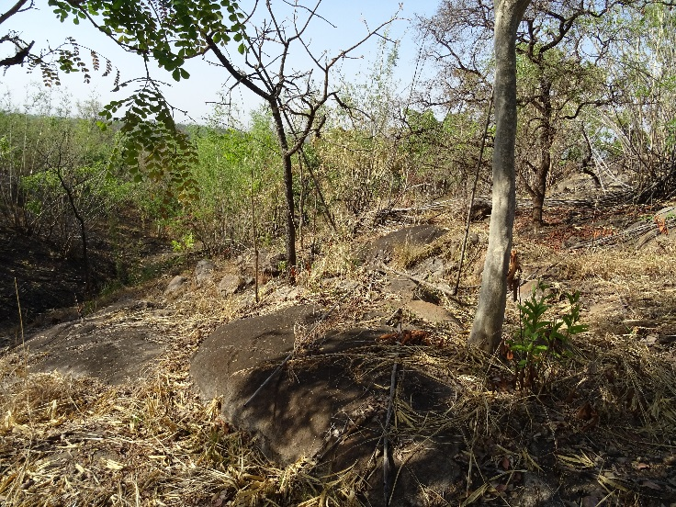 | 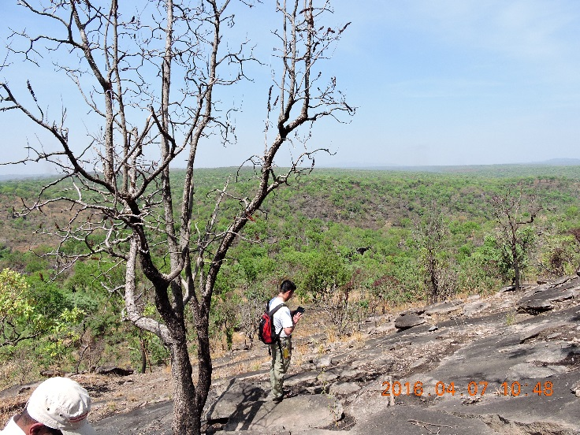
Figure 3.1: Dabus, CH-108, access footpath to dam site.

As one can see from the drawing, starting from the point as described above, a path, 9 km in length, starts and arrives at the powerhouse intersecting numerous times the outline of the penstock. Travel time to the powerhouse is about 4 hours. The following photos show the path taken in order to reach the powerhouse.

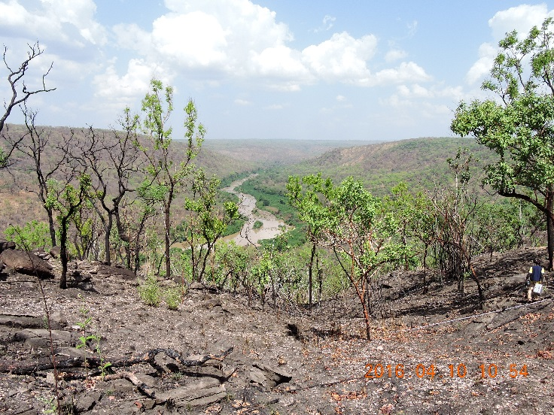 | 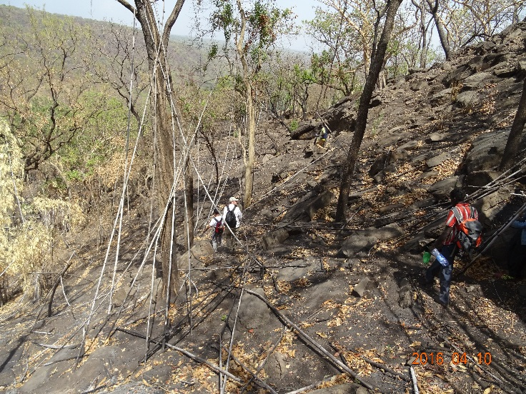
Figure 3.2: Dabus, CH-108, access footpath to Powerhouse.

The Contractor shall evaluate carefully what is needed to transport the equipment to the site in order to perform the investigations without delay. Methodologies proposed for the accesses will be described in the technical proposal as included in the offer.

- DEFINITION of TERMS
In the following, the definition of the terms used in these Terms of Reference (TOR) is given.
This paragraph and the TOR shall be read in combination with Request for Proposal (RFP) and relevant annexes.
The “Contract” means the contract agreement, the letter of acceptance, the letter of tender, these conditions, the specifications, the drawings, the schedules and the further documents (if any) which will be listed in the contract agreement or in the letter of acceptance that shall be signed by the Parties.
The “Party” means the Client or the Contractor, as the context requires.
The “Client” means the person named as client and/or employer in the Contract and the legal successors in title to this person.
The “Contractor” means the person named as contractor in the Contract accepted by the Client and the legal successors in title to this person.
The “Consultant” means the person appointed by the Client to act as the representative of the Client for the purposes of and within the limitations of the Contract, named in the Contract, or other person appointed from time to time by the Client and notified to the Contractor in accordance with the Contract. The Consultant’s staff will include suitably qualified engineers and other professionals. The Consultant, on behalf of the Client, shall have the right to approve, check, certificate, consent, examine, inspect, instruct, notice, propose, request, test or take other similar actions and this shall not relieve the Contractor from any responsibility he has under the Contract.
The “Services” are all the activities the Contractor shall carry out under the Contract in accordance with these Terms of Reference (TOR) and, in particular, as specified and scheduled in the following paragraphs.
The “Standards and Codes” means the latest release of the standards and codes applicable in Ethiopia and the latest release of the internationally recognized standards and codes applicable for the execution of the Services, including but not limited to ASTM, ISRM, AGI.
The “Contractor’s Staff” means all the Contractor’s representative and all personnel whom the Contractor utilizes on Site, who may include the staff, labour and other employees of the Contractor and of each Subcontractor; and any other personnel assisting the Contractor in the execution of the Services.
The “Subcontractor” means any person named in the Contract as a subcontractor, or any person appointed as a subcontractor, for a part of the Services; and the legal successors in title to each of these persons.
The “Contractor’s Equipment” means all apparatus, machinery, vehicles and other things required for the execution and completion of the Services and the remedying of any defects. However, Contractor’s Equipment excludes the Works, Client’s equipment (if any), plant, materials and any other things intended to form or forming part of the Works.
The “Works” means all works of every kind (other than Contractor’s Equipment) required on Site for the execution and completion of the Services and the remedying of any defects.

The “Site” means the places where the Services are to be executed, including storage and working areas, and to which plant, materials and consumables are to be delivered, and any other places as may be specified in the Contract as forming part of the Site.
The “Commencement Date” means the date notified under the Contract.
The “Time for Completion” means the time for completing the Services as stated in the Contract, calculated from the Commencement Date.

- SCOPE of SERVICES
The main objective of the Services is to carry out the Geological and Geotechnical Investigations and provide the necessary input to the geotechnical characterization of the Project sites for the development of the Feasibility Study of the Dabus Hydropower Projects.
The following main activities, but not limited, should be carried out by the Consultant:
- FIELD INVESTIGATIONS
- GEOPHYSICAL INVESTIGATIONS
- LABORATORY TESTS
- CONSTRUCTION MATERIAL INVESTIGATIONS
- CORE STORE
- PREPARATION of DELIVERABLES
The Services shall be carried out according to the applicable Standards and Codes, to internationally recognized best practice and as required to achieve the objectives of the Project. In particular, the Contractor shall comply with the specific technical requirements stated in the following list of attached documents, consisting of:
- Annex A – Drawings
- Annex B – Bill of Quantities
- Annex C – Technical Specifications of Geotechnical Investigations
A description of the activities forming integral part of the Services is given in the following.
  - Field Investigations
The following field investigations are foreseen for the Dabus ch -130 HPP and Dabus ch -108 HPP:
- Boreholes;
- Pits excavation;
- In situ tests.
Mobilization of Contractor’s Staff and Equipment to the Site, including any other things required for the execution and completion of the Services, shall be part of this activity. Works are required to carry out the Services. In particular, the execution of temporary access road and temporary river crossing are required. Maintenance shall be guaranteed during the execution of the Services to keep the Site in proper and safe conditions. At the end of the Services, cleaning, clearing and environmental closure of the Sites is required to the satisfaction of the Consultant.
    - Boreholes
Boreholes are required to determine the geological and geotechnical characteristics of the material involved by works.
The following borehole investigations have been planned:
- N° 15 boreholes on the HPP ch -130 site;
- N° 12 boreholes on the HPP ch -108 site;
The total length is approximately 1820 m (1020 m for HPP ch-130 and 800 m HPP ch-108).
The code, position and lengths of the boreholes to be carried out in the project area are indicated in drawings and summarized below.

Table 5.1.1: Dabus, CH--130, Boreholes list.

Table 5.1.2: Dabus, CH--108, Boreholes list.
General plans of the boreholes are shown in Annex A. The boreholes must be performed according to the Technical Specifications in Annex C.
The boreholes shall be permanently protected by means of a concrete block around top casing pipe for each successful borehole, including locked cover plate and borehole number indication. Piezometric pipes shall be installed in selected boreholes, as directed by the Consultant.
Depending on the evidences of the geotechnical investigations, relocation of planned drilling and/or adjustments to the on-going drilling and/or additional drilling may be required.
    - Pits
The following pits excavation have been planned:
- N° 12 on the HPP ch -130 site;
- N° 2 on the HPP ch -108 site;
The code, position and depth of the pits to be carried out in the project area are indicated in relevant drawings and summarized below.

Table 5.1.3: Dabus, CH--130, Pits list.

Table 5.1.4: Dabus, CH--108, Pits list.

The depth of the pits is indicative. The pit bottom should reach the rock surface; therefore the depth below has to be considered as the maximum depth reachable.
The pits location is shown in the drawing included in Annex A - Drawings. The pits must be performed according to the Technical Specifications in Annex C.
Depending on the evidences of the geotechnical investigations, relocation of planned pits and/or adjustments to the on-going pits and/or additional pits may be required.
    - In situ tests
The following in situ tests are foreseen:
- Permeability tests in boreholes;
- Goodman Jack dilatometer tests;
- Standard penetration tests;
- Marchetti dilatometer test;
- Cone penetration test;
The number and location of the in situ test in the boreholes are shown in the following tables:
Table 5.1.5: Dabus, CH--130, In situ tests in boreholes.

Table 5.1.6: Dabus, CH--108, In situ tests in boreholes.
The following table summarizes the test in the pits. The Marchetti dilatometer test and the Cone Penetration Test with the measurements of the water pressure will be carried out close the piots to correlate the soil stratigraphy with the test results.
The following table summarizes the number and location of the tests:
Table 5.1.7: Dabus, In situ tests in pits.
The tests must be performed according to the Technical Specifications in Annex C.
  - Geophysical investigations
The following investigations have been planned:
- 10,440 m for the HPP ch -130 site;
- 2,880 m for the HPP ch -108 site;
The list of seismic lines together with the coordinates of the seismic lines setting out points, is shown in the following tables for both the HPP projects.
The drawing showing the location of the seismic lines are included in the annex A.
Table 5.2.1: Dabus, CH--130, List of seismic lines.
The following geophysical investigation in the river with hydrophone are foreseen:
- 130 D_SL3 240m
- 130 D_SL9 240m
- 130 D_SL15 240m
- 130 D_SL20 240m

Table 5.2.2: Dabus, CH--108, List of seismic lines.
The geophysical investigations must be performed according to the Technical specification in Annex C.
  - Laboratory Tests
The following laboratory tests are foreseen for the Dabus project:

Table 5.3.1: Dabus, CH--130, List of laboratory tests

Table 5.3.2: Dabus, CH--108, List of laboratory tests

The number of the tests is indicative. The laboratory tests must be foreseen to characterize all the lithologies encountered during the geotechnical campaign. More details regarding the sample collection and laboratory tests will be given by the Consultant during the execution of the geotechnical campaign and according to the progress results. In any case each lithological changes must be characterized.
To concern the river water analysis number 9 samples must be collected.
The laboratory tests must be performed according to the Technical Specification in Annex C.

  - Construction Material Investigations
The following field and laboratory geotechnical investigations are foreseen for the Dabus HPPs project to investigate potential construction materials:
- Borehole
- Geoseismic survey
- Laboratory test
Mobilization of Contractor’s Staff and Equipment to the Site, including any other things required for the execution and completion of the Services, shall be part of this activity. Works are required to carry out the Services. Maintenance shall be guaranteed during the execution of the Services to keep the Site in proper and safe conditions. At the end of the Services, cleaning, clearing and environmental closure of the Site is required to the satisfaction of the Consultant.
    - Boreholes
Vertical boreholes are required to determine the geotechnical characteristics of the rock masses potentially constituting the quarry site.
A number of 3 vertical boreholes are foreseen in the quarry area, the boreholes depth and coordinates are listed in the following table. The boreholes location is show in the relevant drawings included in the Annex A. The boreholes must be performed according to the Technical Specifications in Annex C.

Table 5.4.1: Dabus, CH--130, Quarry list of boreholes

Depending on the evidences of the geotechnical investigations, relocation of planned drilling and/or adjustments to the on-going drilling and/or additional drilling may be required.
    - Geophysical investigations
A total length of 960 m of seismic lines has been planned for the quarry area.
The list of seismic lines together with the coordinates of the seismic lines setting out points for the proposed quarry is shown in the following table.
The drawings showing the location of the seismic lines are included in the annex A.

Table 5.4.2: Dabus, CH--130, Quarry, List of seismic lines.

The geophysical investigations must be performed according to the Technical specification in Annex C.
    - Laboratory tests
More details regarding the sample collection will be given by the Consultant during the execution of the geotechnical campaign and according to in progress results. The list of laboratory tests in shown in the following table.
The laboratory tests must be performed according to the Technical Specifications in Annex C.

Table 5.4.3: Dabus, CH--130, Quarry, List of laboratory test

Table 5.4.4: Dabus, CH--108, Quarry, List of laboratory test
  - Core Store
The Contractor shall construct and equip a core store to store the core boxes and other material from the geotechnical investigations that shall be adequately preserved in time against atmospheric agents, runoff and phreatic water rise, vandalism, etc.
The core store must be constructed according to the Technical Specifications in Annex C.
The core store shall be located in a suitable area, as close as possible to the access road and to the work area, as indicated by the Consultant and/or the Client.
  - Preparation of deliverables
The following draft reports must be delivered during the activities:
  - Monthly progress report, to be submitted every month showing the progress of the works;
  - HPP ch-130 site:
    - Draft Report on boreholes of the DAM AREA, including exact location of the boreholes, complete borehole logs, box samples pictures and results of the in situ tests. Moreover also the information of the pits of the DAM SITE (location, logs, pictures, results of the in situ tests) must be included in the report.
    - Draft Report on boreholes of the WATERWAY and POWERHOUSE areas, including exact location of the boreholes, complete borehole logs, box samples pictures and results of the in situ tests. Moreover also the information of the pits of the WATERWAY area (location, logs, pictures, results of the in situ tests) must be included in the report.
    - Draft Report of the geophysical investigations including exact location of the seismic lines and distribution of seismic velocities vs. chainage and depth along the profiles
  - HPP ch-108 site:
    - Draft Report on boreholes of the DAM AREA, including exact location of the boreholes, complete borehole logs, box samples pictures and results of the in situ tests. Moreover also the information of the pits of the DAM SITE (location, logs, pictures, results of the in situ tests) must be included in the report.
    - Draft Report on boreholes of the WATERWAY and POWERHOUSE areas, including exact location of the boreholes, complete borehole logs, box samples pictures and results of the in situ tests. Moreover also the information of the pits of the WATERWAY area (location, logs, pictures, results of the in situ tests) must be included in the report.
    - Draft Report of the geophysical investigations including exact location of the seismic lines and distribution of seismic velocities vs. chainage and depth along the profiles
  - Draft of the Final Report of the complete Geotechnical Investigations, including Activity 1 - Field Geotechnical Investigations, Activity 2 – Geophysical Investigations, Activity 3 - Laboratory Tests, Activity 4 – Construction Material Investigations, Activity 5 – Core Store as follows:
      - Complete borehole logs, box and samples pictures, results of the in situ tests on boreholes,
      - Complete pits logs, pits and samples pictures, results of the in situ tests
      - Results of laboratory tests of boreholes samples with laboratory certificates,
      - Results of the geophysical investigations including distribution of seismic velocities vs. chainage and depth along the profiles,
      - As built tables and drawings with the exact location of the boreholes and seismic lines according to the coordinate system requested by the Consultant,

Finally, the Contractor, after having received Client's and/or Consultant's observations on the Draft of the Final Report, shall respond to the observations and issue the Final Report of the complete Geotechnical Investigations amended accordingly.

- DURATION OF SERVICES
The estimated Time for Completion of the Services is 180 (one hundred eighty ) days. Out of the total duration days, it has been estimated that 30 (thirty) days will be utilized for the review process of the Draft of the Final Report including response to Client’s observations. Any observations from the Client and/or from the Consultant shall be returned to the Contractor within duration of 15 (fifteen) days from the receipt of the draft deliverables.
The following figure shows a tentative work schedule for the investigations.

- KEY STAFF
The following key staff is required for the Geological and Geotechnical Investigations:
  - Site Project Manager: Geologist or Geotechnical Engineer with at least 10 years of experience;
  - Drilling Rigs Supervisor: Geologist or Engineering Geologist with at least 10 years of experience;
  - Geophysicist: Geologist or Engineering Geologist with at least 10 years of work experience;
  - Chief Drillers: two technician with at least 10 years of experience.
  - Support staff Drillers: two technician with at least 5 years of experience.

- DELIVERABLES, MEETING and SCHEDULE
The following report must be delivered during the activities, as described in previous paragraph relevant to “Preparation of deliverables” of the services:
  - Monthly progress report, to be submitted every month;
  - HPP ch-130 site:
    - Draft Report on boreholes of the DAM AREA
    - Draft Report on boreholes of the WATERWAY and POWERHOUSE areas
    - Draft Report of the geophysical investigations
  - HPP ch-108 site:
    - Draft Report on boreholes of the DAM AREA.
    - Draft Report on boreholes of the WATERWAY and POWERHOUSE areas
    - Draft Report of the geophysical investigations
  - Draft of the Final Report of the complete Geotechnical Investigations
Each report must be delivered as follows:
- N° 5 hardcopies
- N° 3 softcopies

- PAYMENT SCHEDULE
The modality of payment shall be in accordance with the terms and conditions of the contract document to be signed between toe MoWIE and the Contractor following negotiation. The following indicative schedule may hover serve as a basis of negotiation:
- First Invoice: No Advance Payment to be issued.
- Monthly Invoices: As soon as practicable and not later than ten (10) days after the end of each calendar month during the period of the Services.
- Final Invoice: upon completion of Services as certified by Consultant.

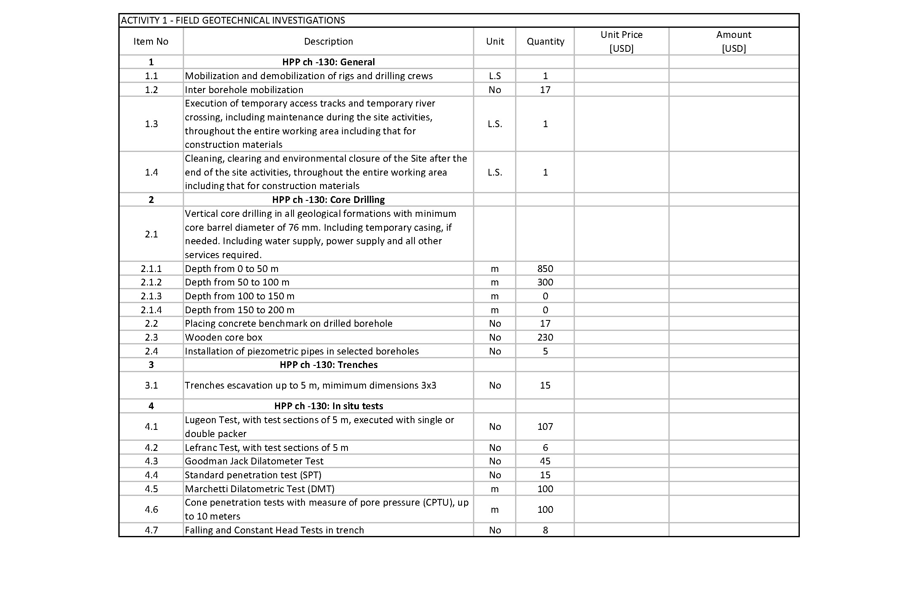

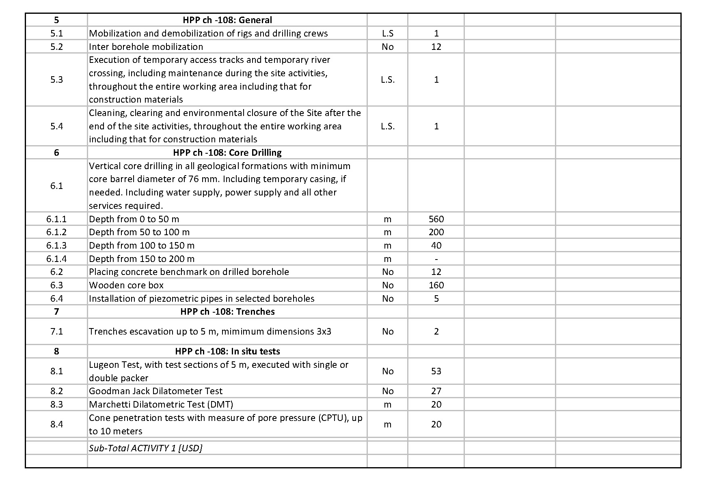

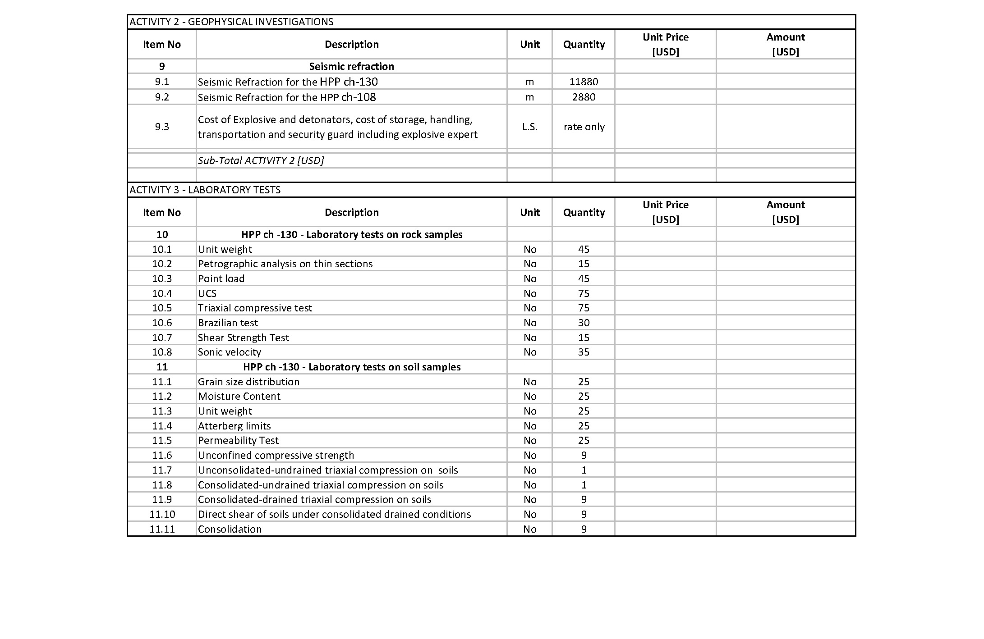
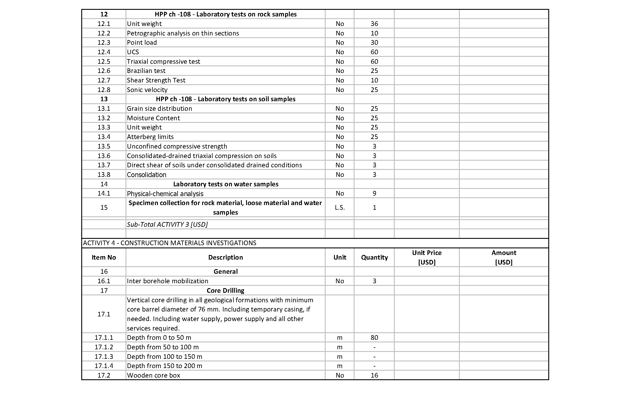

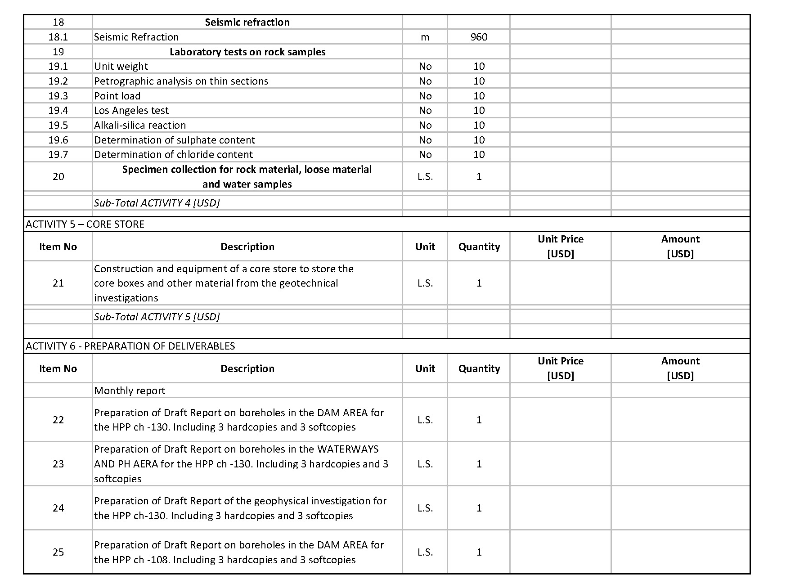

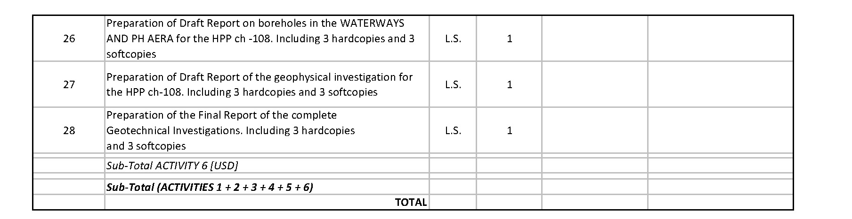

PART 2 SPACIFICATION

INDEX
Paragraph Subject Page
1 CONTENT 1
2 DRILLING OPERATIONS 1
2.1 Description 1
2.2 Equipment and Materials 1
2.3 Core recovery 2
2.4 Casing 3
2.5 Flush water or drilling fluid supply 3
2.6 Drilling bits, core barrels and core boxes 4
2.7 Soil Sampling 4
2.8 Rock Sampling 5
2.9 Water level measurement 5
2.10 Borehole logs 5
2.11 Piezometer pipes installation 7
3 TRENCHES 7
3.1 Introduction 7
3.2 Trenches excavation 8
3.3 Trench Inspection 8
3.4 Trench Report 8
4 IN SITU TESTS 9
4.1 Permeability tests 9
4.1.1 Introduction 9
4.1.2 Water Pressure Tests (Lugeon) 9
4.1.3 Falling And Constant Head Percolation Tests (Lefranc) 12
4.2 Goodman Jack Dilatometer Test 13
4.3 Standard penetration tests (SPT) 14
4.4 Marchetti Dilatometric Test (DMT) 17
4.5 Cone penetration tests with measure of pore pressure (CPTU) 18
4.6 Falling and Constant Head Tests in trench 20
5 GEOPHYSICAL INVESTIGATIONS 22
5.1 General 22
5.2 Seismic Refraction Method 22
5.3 River Bed Geophysical Surveys 24
6 SAMPLING and LABORATORY TESTING of SOIL and ROCK 25
6.1 General 25
6.2 Sampling 25
6.3 Undisturbed soil sampling 25
6.4 Laboratory tests 26
7 PHYSICAL-CHEMICAL ANALYSIS on WATER SAMPLES 28
7.1 General 28
7.2 Determination of sulphate content 28
7.3 Determination of chloride content 29
8 CORE STORE 30

- CONTENT
This document illustrates the technical specifications of the Geotechnical Investigations (boreholes, Test Pits, geophysical investigations, and site and laboratory tests) to be carried out at the Dabus cascade project area.
The following technical specifications shall be read in combination with the relevant Request for Proposal (RFP), Terms of Reference (TOR), Bill of Quantities (BOQ) and Drawings.

The Services shall be carried out according to the latest release of the standards and codes applicable in Ethiopia, to the last release of the applicable international standards and codes, including but not limited to ASTM, AASTHO, ISRM, EN ISO, AGI, to the internationally recognized best practice and as required to achieve the objectives of the Project.
The language of deliverables, including tables, drawings and any other attachment forming part of the deliverables, shall be English, in form acceptable to the Client and/or Consultant.
- DRILLING OPERATIONS
  - Description
The work involves drilling thorough the following soil and rock material:
- ALLUVIAL SOIL
- RESIDUAL SOIL META GRANITE
- RESIDUAL SOIL META GRANODIORITE
- META GRANITE
- META GRANODIORITE

The investigation programme envisages vertical core drilling to depths ranging from 20 to 120 m.
  - Equipment and Materials
At the start of the works, the Contractor shall have a sufficient number of rotary drilling rigs on sites, ancillary equipment and crews in order to execute all works required AS per these specifications. The amount and type of equipment shall be appropriate for the depth and diameter of the proposed boreholes, as well as the type of soil and rock expected according to the given specifications.
All drilling equipment and accessories shall comply with the requirements of internationally recognized standards and possess the required capacities to obtain the maximum recovery of high quality cores in the anticipated soils and rocks.

All equipment shall be well maintained at all times and suitable for the specified work.
All machines shall be adjustable in a sufficiently wide range of rotational speeds between 0 and 500 rpm, and shall allow easy and smooth speed adjustment in order to operate in any rock or soil formation in the optimal range. Indicators for drilling pressure and proper control on the drill bit are required.
Sufficient water supply for drilling and water tests (Falling Head and Water Pressure tests) must be provided.
A minimum of two (2) pumps and a barrel for water storage will be necessary for each rig.
The Contractor shall have available at all times at the job site all materials and supplies, fuels and lubricants, core boxes and the like required to sustain the drilling operations to ensure timely execution of the work.

The Contractor’s equipment, ancillary devices and accessories at the site shall include but not be limited to the following:
- The drilling machines shall be equipped with suitable indicators for drilling pressure and torque; transmission gears capable for adjusting the spindle rotating speeds between 0 and 500 rpm continuously; suitable conventional single and double core barrels; suitable diameter drill rods, diamond drill bits for all kinds of rock and soil found at the job site; casing pipes; and equipment or special devices and spare parts to deal promptly with routine incidents or accidents.
- Any other facilities such as ropes, winches, skids and special towing means, which may be required for safe access of equipment to locations not directly accessible by normal access roads.
- Pumps for providing flush water with a minimum output of 150 litres per minute. In addition, a sufficient number of high head supply pumps has to be supplied for bridging differences of elevation.
- Flushing and cutting tools (fishing bell tap, core tap, etc.) shall be provided.
- Electrical water table gauges.
- Sufficient number of pipes, casings and bits for various borehole diameters shall be provided at the project site to avoid delays.
  - Core recovery
Continuous core recovery shall be carried out in all boreholes as shown in the annexed drawings and in the Bill of Quantities.
Core recovery shall in general be between ninety (90%) and one hundred (100%) percent.
The Contractor shall use the double core barrel equipment for core recovery drillings.
The Contractor may choose the initial and intermediate diameters of each hole for his own convenience, provided that he will be able to produce the minimum acceptable hole diameter of 76 mm at the anticipated depth of the borehole.
The maximum length of any core run shall be 3 m but this maximum shall be reduced in any of the following circumstances:
- If over the previous stretch of 3 m of core run the average core recovery has been less than 90 percent.
- If other methods of sampling or in-situ testing are required at less than 3.0 m intervals. Notwithstanding the above, the core barrel shall be removed from the drill holes as often as necessary in order to obtain the best possible core recovery. When core recovery is less than 90 percent in any core run, the next two core runs shall be reduced in length to a maximum of one (1) meter. In heavily fractured or altered zones and in soil formations, core runs shall not be more than 1 m.
  - Casing
The Contractor shall provide steel casings as required to ensure the stability of the drill hole in loose formations. The casings shall permit the passage and operation within the borehole of all the required drilling, sampling, in-situ testing, instrumentation, monitoring and all other works to be performed by the Contractor as specified in this document or as required by the Consultant.
A sufficient amount of casing pipes must be provided at site for all holes in structure foundations, as casing pipes installed in these holes, shall not be removed until all works are completed or as directed by the Consultant.
The top of the casing shall be threaded and closed by a cap.
  - Flush water or drilling fluid supply
Clean water or polymer mud may be used as drilling fluid.
The Contractor shall select, for the approval of the Consultant, the most appropriate drilling fluid to obtain the required quality and recovery of cores in the prevailing conditions with the minimum permeation of the cores by the fluid used.
The Contractor shall obtain from the supplier or manufacturer full details of the constituents of the drilling fluid to be used. The type and composition of the fluid used at each borehole shall be clearly identified in the Contractor's Report.
The fluid type shall not be changed without the prior approval of the Consultant. However, the Contractor shall use clean water as drilling fluid whenever requested by the Consultant.
The use of clean water is required in the case of permeability tests execution.
Facilities for adequate capacity water tanks may be required at some and/or all drill holes sites.
Any drilling fluid other than clean water shall be prepared and stored in suitable leak-proof containers or tanks and used drilling fluid other than clean water returning from the borehole shall be recollected until it is either re-used or disposed of at an approved location.
The fluid used shall not in any way contaminate the ground water or river system.
  - Drilling bits, core barrels and core boxes
The diamond drill bits shall ensure the required percentage of core recovery and the specified quality thereof. Worn bits shall be replaced immediately in order to avoid any alteration in the quality of work.
The type of core barrel used should ensure the required percentage of core recovery and the specified quality.
The double tube barrels equipped for face ejection shall be included in equipment supplied and used as appropriate.
Each core box shall be provided with a strong hinged lid with a minimum of two hinges and secured by a strong hasp and staple. A simple device allowing both firm and secure box closure and easy opening shall be attached to each box. The lid and base of the box shall be strengthened with ribs. The timber used shall be highly resistant to deterioration by insects and weather.
The core box shall be identified both on the inside of the lid and outside on one long and one short side of the box with the scheme site, borehole number, core depth section and core box number. The markings shall be performed using a durable washer ink or paint.

Each core run shall be separated by a small wood block. The core divider shall be marked with arrows to indicate the top to bottom of core runs. The depth of each core run shall be indicated on the wood blocks.
Zones of core loss or removed core samples shall be identified by wooden blocks properly marked and fixed at the appropriate locations.
Cores shall never be broken on purpose, except at 1 m section lengths to fit them into the core boxes. When a core is broken either accidentally or to fit into core boxes, the Contractor shall clearly mark such breaks on the core.

Each core box will be photographed using a digital camera within 24 hours from completion. All reference information shall be clearly indicated on the box. Cores shall be wetted prior to photography.

Where cores within plastic liners must be examined or photographed and logged, the liner shall be carefully cut by the Contractor without damaging the core inside.
After each core section is unsealed, the Consultant might select samples for possible laboratory testing.
  - Soil Sampling
The Contractor shall seal with paraffin wax and muslin, label, store and transport these samples to the laboratory according to the standard ASTM D-4220 procedures, or any special instructions given by the Consultant on site. All unsealed cores shall be photographed, logged and then be resealed again in the shortest possible time required for the correct performance of these procedures. Loss of moisture shall be retarded by covering exposed core with damp cloth.
Drilling shall not be authorized by the Consultant unless sufficient core boxes and sealing materials are available on site for the immediate storage of core recovered from a borehole.
The core boxes will be delivered to the Client at the end of the assignment.
  - Rock Sampling
When engineering properties are to be determined for the core, from the time the core is recovered from the core drill until testing is performed, it must be handled and preserved in such a way that the measured properties are not significantly influenced by mechanical damage, changes in chemistry, and environmental conditions of moisture and temperature. Drill core shall also be considered as the sample record for the subsurface geology at the borehole location, and as such must be preserved for some period of time, in some cases indefinitely, for future geological study. For this purpose the Contractor has to manage all samples according to the standard procedures of ASTM D 5079. These practices cover the preservation, transportation, storage, cataloging, retrieval, and post-test disposal of rock core samples obtained for testing purposes and/or geological/geotechnical study.
  - Water level measurement
The drilling fluid levels shall be observed and recorded as follows:
- Drilling fluid levels in the borehole shall be recorded at the beginning and end of each shift.
- Drilling fluid levels shall be recorded immediately whenever any significant change in level occurs as a result of suspected fluids loss into the ground or groundwater entry into the borehole.
- On each occasion when the drilling fluid levels are recorded, also the depth of the borehole, the length of each casing size inserted into the borehole and the time and date shall also be recorded.
  - Borehole logs
During drilling operations progress, the Contractor’s geologist shall record all relevant data and significant observations which shall be reported in the borehole logs.
These records, which shall be recorded in a standard format that shall be preliminarily sent to the Consultant for approval, shall include:
- Drilling Information
  - Borehole number
  - Location
  - Ground Elevation
  - Max. depth reached
  - Commencement date
  - Finishing date
  - Name of geologist directing operations
- Drilling procedure
  - Type of drill rig, drilling method
  - Flushing system
  - Borehole diameter
  - Type of bit
  - Casing pipe
- Drilling progress
  - Daily depths
  - Speed of advance
  - Drilling pressure
  - Drilling torque
  - Rotation speed
- Geological and geotechnical data
  - Percentage of core recovery
  - RQD (rock quality designation)
  - Fracture frequency
  - Alteration degree
  - Water level (m)
  - Stratigraphy description (according to ISRM Standard)
  - Sample number and depth
  - Presence of cavities and dimensions
- Permeability test (Lugeon)
  - Water pressure (MPa)
  - Water losses for each 10 min stage (l)
  - Rate of absorption (l/minxm)
- Goodman Jack Dilatometer test
  - Test depth for each dilatometer test, with code number
- Standard penetration tests
  - Test depth for each test with the number of blows required
Furthermore, photographic documentation of the drilling works shall be provided with particular regard to:
- core boxes
- sampling operations
- any significant situation which may occur
Upon Consultant’s request, the Contractor shall make available any preliminary field stratigraphy.
  - Piezometer pipes installation
Installation of rigid micro-slotted PVC pipes are required after completion of the borehole, where shown on the relevant documents or directed by the Consultant.
Piezometer pipes are used to allow measurements and monitor water levels in the boreholes.
Depending on stratigraphy, results of the permeability tests and the actual boreholes water level, the piezometer pipe can typically be of two types:
- Standard pipe
- Casagrande pipe
For the standard pipe, no bentonite seal is allowed other than at the ground surface. The whole borehole should be backfilled with clean and washed sand. The following materials shall be made available during drilling operations: washed sand, depth meter, teflon tape, adhesive tape and a hacksaw.
Once the borehole has been completed:
  - insert the piezometer pipes
  - lift up the casing
  - check again bottom depth with the meter
  - use teflon tape on the threaded ends of the tubes pieces
  - cut the PVC tubes with a hacksaw at about 20 cm over the ground level
  - Complete the operation by making a cement block on the surface and installing the protection of the piezometer pipe column head.
For the Casagrande pipe, clean sand should be poured down into the hole to create a sand pack around the piezometer window. A weighted cloth measuring tape may be used to check that the sand has reached a point 0.6m above the top of the piezometer window. The poured sand should be allowed to be well settled. Bentonite pellets should be used to form a seal layer of at least 0.5m thick above the sand pack. The pellets should be allowed to be well expanded to seal off the borehole. The rest of the borehole should be grouted to surface by bentonite-cement grout to prevent vertical migration of water.
The top of the borehole shall be sealed with concrete to prevent the entrance of surface water.
The top of the piezometer should be covered by an end (screw) cap or wooden plug through which a small hole should be drilled for ventilation purpose, or cut a notch to allow air into the pipe thus allowing the water lever to reach its natural head.
- TRENCHES TEST PITS
  - Introduction
A number of 15 trenches Test Pits shall be performed to:
- Investigate the stratigraphy of the weathering profile;
- Gather samples for laboratory tests;
- Perform permeability tests;

The trenches position is shown in the relevant drawings.
  - Trenches Test Pit excavation
The Excavation will be carried out either by using an excavator or dozer, depending on the characteristics of the foundation material, depth and dimensions of the trenches to be excavated.
The minimum dimension for the trench will be 3.0 x 3.0 m, or as directed by the Consultant.
The geometry of the trench Test pit slopes shall be such as to guarantee stability of the excavation and the safety of the personnel. The geometry of the trench slopes shall guarantee the stability of the excavation and the safety of the personnel. Once the trenches have been inspected, they will be re-filled using the same excavated material and will be compacted by the excavator.

  - Trench Test Pit Inspection
The Inspection of the trenches foresees:
- description of the formations encountered;
- description of the bedrock type, if any;
- measurement of the water table, if present;
- taking of samples as requested by the Consultant;
- execution of permeability tests using falling head method.
  - Trench Report
Logs shall be kept for each trench and will contain the following information:
- date of excavation
- trench test pit number
- coordinates of at least three corners of the trench
- type of excavator used
- maximum depth reached
- description and stratigraphy of soils
- level of water tables if present
- type, number, location, volume and weight of samples taken from the test pit trench
- raw data, results and diagrams relative to water tests.

In addition to the above, photographic documentation, describing the stratigraphy of soils and sampling operations, shall be provided.

- IN SITU TESTS

  - Permeability tests
    - Introduction
Water pressure tests using the Lugeon method shall be carried out in core drilling in rock material.
Percolation tests using the Lefranc method shall be carried out in core drilling in decomposed materials or soils.
Head or falling tests shall be carried out in test pit trenches.
The number and location of the tests are indicated in the attached drawings.

    - Water Pressure Tests (Lugeon)
Lugeon tests has to be executed according to the applicable international standard and the internationally recognized best practice.

EQUIPMENT AND MATERIALS
The following equipment is necessary in order to carry out the LUGEON water pressure tests:
- Single packer, for advancement tests, hydraulically or mechanically expandable;
- Double packer, for upward tests, with hydraulically expandable membrane. The tube which links the two expandable pistons will have a perforated surface area A ≥ 2At, with At the surface area of the tube section;
- Centrifugal pump able to reach injection pressures of 1 MPa;
- Water meters with an accuracy of 10% referring to the actual reading;
- Pressure gauge, with sufficient precision to permit 0.5 atm readings, and a calibration certificate;
- Hydraulic intake tubes;
- Independent pressure measuring circuit linked to the test chamber, with calibrated gauge.

CALIBRATION
The water meter shall be calibrated on site, before commencement of the tests, by filling a container with known volume greater than 100 l.
If there is no independent pressure measuring circuit, the load losses in the intake tubes will be evaluated on site by using a sampling tube place horizontally on the surface and linked to the pump with the pressure gauge.
The load loss will be calculated corresponding to the flow Q as Pc = P/l where:
Pc = load loss per linear meter (kPa/m)
P = pressure at gauge (kPa)
l = length of tube (m)

The test will be repeated for at least 3 different flow values Q.

TEST OPERATION
The test can be performed with single packer equipment (advancement Test) or with a double packer equipment (upward test).

Prior to the start of the test drill hole shall be adequately flushed with clean water for a period of 15 minutes. The water shall then be removed from the hole, underground water level, if any, ascertained by two measurements 10 to 30 minutes later, and the packer inserted.
As a rule the test section length shall be 5 m.

If on the other hand the drill core from the test section is not homogeneous, shorter test sections may be ordered by the Consultant and noted in the drill log book.

Attention shall be given to set the packers at borehole sections with relatively good core quality in order to guarantee a good sealing of the packers. If each packer is not sealing well and a backflow of water can be observed, the search for a more suitable and watertight packer location shall be sought.

For the single packer test, where a test has been scheduled, the drilling shall be interrupted and the test performed over the lowest 5 meter of drill hole. For this purpose a packer will be fixed in the drill hole so that the sealing packer is located 5 meters (or as the Consultant may specify) above the bottom of the drill hole.

The set-up of the testing equipment on site shall be in the following order:
- The pressure recorder or manometer shall be mounted on the water pipe leading to the packer immediately on top of the borehole collar at an height and position convenient for continuous observation and readings.
- Shortly behind, in direction to the water pump the recorder or flow meter to be straight visible from the pump control panel
- A controlled bypass with valve, installed between pump and flow recorder, allows the control and adjustment of the flow and pressure.

The water to be used for the test should be clear, free of sediments and suspended matter.
The test shall be performed in cycles of increasing and subsequently decreasing pressure steps. Each pressure step shall last for at least ten (10) minutes, during which the pressure shall be kept constant. Water absorption shall be read every minute.

After ten (10) minutes of stable pressure and steady flow, the pressure shall be adjusted to the next pressure step according to the testing scheme.

The maximum water pressure in each test shall not exceed the corresponding weight of the overlying rock and soil, unless otherwise instructed by the Consultant.

The following table shows a tentative programme of pressure stages:

Rock Quality | Pressure Steps (MPa)
Clastic rock, very poor rock, at depth <5 m | 0.05 | 0.15 | 0.25 | 0.15 | 0.05
Poor rock | 0.1 | 0.2 | 0.3 | 0.2 | 0.1
Fair rock | 0.1 | 0.3 | 0.5 | 0.3 | 0.1
Good rock | 0.3 | 0.5 | 1 | 0.5 | 0.3

In case of unusually high absorption rates, exceeding the maximum pump discharge capacity and not allowing for the required pressure build up, the length of the test section shall be diminished by lowering the
packer, until the pump discharge capacity exceeds the water intake in the test section. A minimum test section of 1 m shall however be guaranteed.

WATER PRESSURE TEST REPORTS

Each water pressure test shall be described by the Contractor in a report including the following data:
  - Date of test
  - Number of hole
  - Borehole collar level
  - Borehole Diameter
  - Depth of packer below ground level
  - Test section length (m)
  - Groundwater level, if present (m) below GL
  - Height of pressure gauge above ground level (m)
  - Pipe length and diameter
  - Start time and time of successive measurement (min)
  - Charts from the recording pressure/time and flow/time gauges
  - Table and graph of pressure/flow covering the full range of pressure
  - Rate of absorption (l/(m x min))
  - Rate of absorption in Lugeon unit (l/(m x min)) at 1 MPa
    - Falling And Constant Head Percolation Tests (Lefranc)
Falling and constant head percolation tests shall be carried where no packer be fixed for example decomposed material.
Such tests could be also required, where permeability, is so high that water intake under pressure exceeds the capacity of the pump or in deep boreholes with a low ground water level.

The falling head method shall be applied in cases of low permeability.
The constant head method shall be applied in cases of high permeability.

EQUIPMENT AND MATERIALS
The following equipment is necessary for the percolation tests:
  - Stand pipes (casing)
  - Electric flow gauge
  - Stopwatch
  - Pump with capacity of at least 150 l/min
  - Water pipes and supply facilities

Water used to perform the falling and constant head percolation test shall be clean and free of sand and silt. If necessary the Contractor shall have settlement tanks of adequate capacity to remove unwanted sediment.

TEST OPERATIONS
Preliminary operation shall be as follows:
  - Interruption of core drilling at the depth scheduled for the permeability test.
  - Lowering of casing down to the bottom of the borehole without using drilling fluid for at least the last 1 m
  - Pouring of well washed gravel into the casing for a depth of 60 cm from the bottom
  - Lifting of casing for 50 cm without use of drilling fluid
  - Reiterated readings of ground water level
  - If groundwater is not present in the borehole, continuous circulation of clean water for at least 30 minutes shall be guaranteed.

EXECUTION OF TEST
a) Falling Head Method
  - Fill borehole with clean water up to the top of casing
  - Stop water supply
  - Measure descending water levels at regular intervals of 14 minutes, 30 minutes, 1 hour, 2 hours, 8 hours, 15 hours from the start of falling head until bottom of hole or ground water level has been reached.

b) Constant Head Method
  - Pour clean water in the casing until a constant head is reached corresponding to a steady flow in the ground.
  - Steady flow conditions and constant head shall be maintained for at least 10 minutes with water being supplied through metering system.
  - After completion of the tes at constant head, descending water levels shall be measured at intervals of 15 minutes, 30 minutes, 1 hour, 2 hours, 4 hours, 8 hours, 15 hours until the bottom of the hole or the ground water level is reached.

PERCOLATION TESTS REPORTS
For these preliminary tests, the brief data report for each borehole shall include the following data:
- date of test
- number of borehole
- borehole collar elevation
- depth of borehole at the time of performing the test
- casing length and casing collar level above the ground
- casing inner diameter
- time of start and completion of test
- water table elevation before and after the completion of the test

For falling head test:
- water level readings

For constant head test:
- water head
- measurement of added water volume per minute

  - Goodman Jack Dilatometer Test
Dilatometer test will be used to measure in situ rock mass deformation modulus (E) at different depths. They will be executed inside boreholes by means of the Goodman Jack,

The Goodman Jack consists of an hydraulic jack with curved bearing plates, LVDT sensors, a displacement indicator, an hydraulic pump with pressure gauge, hydraulic hose, electrical cable, and a coupler for drill rod.
The jack is attached to drill rod and inserted into the borehole. An hand pump is used to create hydraulic pressure in the lines connected to the jack, which in turn activates the pistons and produces a uniform and unidirectional stress field at the bearing plate. The applied hydraulic pressure is measured with a standard Bourdon-type pressure gauge. The deformation of the rock is measured by two Linear Variable Differential Transformers (LVDT) and data are displayed by the indicator at the surface. After the test has been completed, the bearing plates are retracted by reversed pistons and the jack is withdrawn from the borehole.
The modulus of deformation is calculated using formulae empirically derived from in-situ testing and correction factors that were developed by laboratory testing.

Test Report documentation shall include:
- general site information (site name, location, date, operator name);
- name of the tested borehole;
- test depth and elevation;
- water level;
- on site data readings;
- data processing;
- calibration certificate;
- notes and observations.

  - Standard penetration tests (SPT)
Standard Penetration Tests (SPT) will be performed during drilling the boreholes foreseen in order to measure the friction angle of the ground. The tests have to be carried out according to the standards ASTM D1586 - 08a.

The number of Standard Penetration Test (SPT) tests is indicated in the annexed BOQ. Generally the first test will be executed at 3 m depth from ground foundation level. Following tests will be executed at 2 m interval during drilling.

The SPT test standard procedure consists in blow-driving a sample-rod standard thick wall (Raymond Sampler), reaching the end of a borehole and recording the number of blows required to penetrate a 30cm depth (NSPT).

EQUIPMENT AND MATERIALS
The equipment consists in:
  - a sample-rod (Raymond sampler), must have smooth (inner and external) surfaces and be opened lengthwise. The external diameter must equal 51 ± 1 mm, that internal 35 ± 1 mm, and the minimum length (excluding the end cutting skid) must be of 457mm. The skid shoe, sharply tapered at the last 19mm to favour penetration, must be 76 ± 1 mm long. The (inner and external) diameters must be identical to the sampler dimensions. Moreover, the sampler must be equipped at the top with a spherical valve and discharge opening (breather) for allow the exit of air, water or mud during penetration. The valve must be water proof during sampler extraction. If required, into coarse granular soil conic shoe could be employed instead of the standard open cutting shoe.
  - An appropriate number of rods to perform the required tests. Rods weighing over 10Kg per linear meter are not allowed.
  - A hammering mass not exceeding 115Kg, including :
    - hammer (or hammering mass) in steel, weight 63.5 ± 0.5 kg;
    - hammer slide and release with automatic unhooking, must allow the hammer a guided free-drop of 760 ± 10 mm with negligible friction.

TEST OPERATIONS
The test is carried out on boreholes whose diameters are no larger than 150 mm.
The hole must be cleaned and substantially undisturbed at the test elevation, without appreciable upward gradients. In case the test is performed below the piezometric surface level, the fluid level in the hole must always be kept above the hydrostatic level.
The hole bottom elevation must be controlled using the proper sounding line and collated with the measurements obtained by drilling or during prior cleaning; during control, it can occur that the measured elevation be higher than the hole bottom due to reflows or the settlement of suspended detritus; in case the difference exceed 7cm, the test cannot be performed and the hole must be cleaned again.
The test is carried out by hammering the sampler to the bottom of the hole for two consecutive stretches, the first 150mm and the second 300mm, and recording the number of blows necessary for penetration. The operations sequence is:
  - perform the preliminary 150mm hammering stretch, count and record the number of hammer blows up to a maximum of 50 blows;
  - perform the 300mm stretch, count and record separately the number of blows for the first and second 150mm hammer-blows up to a total of 100 blows maximum; rejection is so considered when after the preliminary hammering, equal to 150 mm or 50 hammer-blows, one obtains 100 blows for a progress lower of equal to 300mm; in case of rejection, the hammering depth increase corresponding to 100 blows must be recorded (in cm); the blow frequency in all test phases must not exceed 30blows per minute;
  - at the end of the hammering, when the 450mm depth increase has been achieved, the sampler is carefully extracted;
  - at the end of the extraction, open the sampler, measure and describe the collected sample, disregard eventual top part formed by detritus and seal it in a cylindrical airtight (plastic bag or jar) container that allow the sample to be examined without mixing the various parts.
  - On extracted samples grain-size laboratory tests will be carried out.

TEST REPORTS
A label including the following information will be fixed onto each container:
- work site;
- test identification number;
- sample number;
- test depth;
- sample length;
- test date, and
- number of blows per each 15cm stretch.

Moreover, the documentation supplied must contain the following information on each test carried out to a given depth:
- general information (project, worksite, location, date, operator name);
- survey number;
- drilling method and diameter;
- type of shoe (open or conic);
- hammer type and release device;
- pole diameter and weight per linear meter;
- covering diameter, if used;
- depth of covering base, if used;
- depth of water table and drilling fluid in hole;
- depth reached after drilling and cleaning;
- test start in depth;
- initial penetration per sampler rod typical weight;
- number of blows necessary to cover the preliminary and test stretches;
- length and geotechnical description of the extracted sample, and
- observations and any useful notes.

  - Marchetti Dilatometric Test (DMT)
The dilatometer test shall be carried out to measure mainly the following parameters: Eeod (constrained modulus), Ed (dilatometer modulus), Kd (horizontal stress index) and Phi.
The dilatometer test, by means of Marchetti dilatometer (DMT), has to be executed inserting the DMT into the soil with a drill rig.
The drill rig may be used especially in hard soils, when the soil contains occasional boulders or hard layers, or when very deep soundings are requested.
When a drill rig is used, the dilatometer is pushed into the soil with a particular unit named “Torpedo”.
Location of the tests will be established following the instructions given by the Consultant.

EQUIPMENT AND MATERIALS

The Torpedo is constituted by the following components:
- upper adaptor to connect the drill rods to the torpedo;
- two or three torpedo rods (usually) 1 meter long each one;
- lower adaptor to connect the torpedo to the DMT.

The upper adaptor for the drill rods is a cylindrical steel element, with a hole and a groove to allow the exit of the electro-pneumatic DMT cable, and with a steel collar to protect the cable from breaking up against the wall of the borehole.

TEST OPERATIONS
The pushing capacity of a drill rig, required for inserting dilatometer, is light, and usually lower than 2 t. For this reason the DMT test with the drill rig has to be executed repeating the pushing of the dilatometer and the boring, alternately.

The Torpedo is pre-assembled before starting the test and then fixed to the end of the rods each time that the test has to be repeated. It is unfixed before executing a new operation of boring.
The steps of the test, starting from the ground level, are:
  - position the DMT torpedo on the ground level;
  - Push the DMT 20 cm down, then take A and B readings;
  - Continue with DMT insertion taking A and B readings, every 20 cm, until the limit of the pushing system, or stopping before that the exit of cable reaches the soil level (to avoid a rupture of the cable);
  - extract the torpedo;
  - drill and remove the soil that was penetrated and tested by the blade, thereby advancing the borehole down to the max depth previously reached by the blade minus 20-30 cm, to avoid the disturbance of the corer in the undisturbated soil in which DMT will take the new first A and B reading;
  - lower the torpedo down to the bottom of the hole and start again repeating c) d) e) steps.

The sequence of the steps is illustrated in the following figure

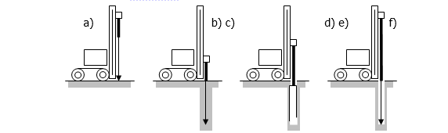
Fig. 1 – Steps in a DMT test with drill rig and Torpedo

The pneumatic cable must be taped on the drilling rods every 2.0 – 3.0 m interval during the lowering of the torpedo into the borehole. This operation minimize the risk to break the cable between the rods and the wall of the borehole or of the casing.
The length of the torpedo limits the test depth because the operator must always stop the penetration when the upper adaptor, and the cable coming out from the hole, is close to the soil level.

When the DMT sounding is resumed after preboring, the initial test results, obtained in the zone of disturbance at hole bottom (about 3 to 5 borehole diameters), should be regarded carefully.
The minimum recommended distance from other nearby DMT soundings is 1 m (25 diameters from unbackfilled/uncased borings).

DMT test will be executed according to the ASTM D-6635 (2007) standard.

  - Cone penetration tests with measure of pore pressure (CPTU)
Cone Penetration Tests (CPTU) with measurement of pore pressure will be performed in order to measure the resistance to penetration and the frictional resistance of the subsurface soils. This test determines also pore pressure development during push of the piezocone penetrometer. The tests have to be carried out according to the standards ASTM D 5778.

The number of Cone Penetration Tests (CPTU) with measurement of pore pressure is indicated in the annexed BOQ.

The CPTU test standard procedure consists in to drive a penetrometer tip with a conical point through the soil at a constant rate of 20 mm/s.

EQUIPMENT AND MATERIALS
The equipment consists in:
- A friction cone penetrometer, which should be meet the requirements as given in the standards ASTM D 5778.
- A measuring system. The signals from the penetrometer transducers are to be displayed at the surface during testing as a continuously updated against depth. The data are also to be recorded electronically.
- An appropriate number of steel rod to perform the required tests. The rod are required having a cross section area adequate to sustain, without buckling, the thrust required to advance the penetrometer tip.
- A friction reducer to reduce rod friction. The type, size, amount and location of friction reducer(s) used during testing must be reported.
- A trust machine that should be capable of adjusting push direction through the use of a levelling system such that push initiates in a vertical orientation. The thrust machine must be anchored so that it provides the necessary reaction for the penetrometer and does not move relative to the soil surface during thrust. It is requested a machine with a thrust capability of not less than 20 tons.
The full description of equipment and materials is reported in ASTM D5778.

TEST OPERATIONS
For the soundings, the penetrometer thrust system of the CPT truck or drill rig must be set to as near vertical as possible. For penetration in compacted fills or hard soils, it may be necessary to prebore a hole through the upper material, using a diameter slightly larger than the cone. This will prevent damage to the cone. Before beginning the sounding, check individual push rods for straightness.
If obstructions are encountered up to 5 meters from the ground, a preboring must be realized in order to allow to continue the CPT test.
Test will be stopped after 5 meters if the soil resistance is higher than the thrust capacity of the machine. All the procedures reported in ASTM in case of excessive thrust capacity must be realized before stopping the test.

The standard rate of push for CPT soundings is 2 centimetres per second (cm/s), usually applied in 1 meter increments, the length of a standard cone rod.
During testing, monitor the tip and sleeve forces continuously for signs of proper operation. As data are recorded, note any unusual occurrences in testing.
These can include “crunching” sounds that may indicate gravel and directional drift of the penetrometer as it passes through or alongside obstructions such as boulders, cobbles, soil concretions, or thin rock layers.
Inclination is a useful indicator of imminent danger to the system, as damage can be caused if resistant layers or obstructions are penetrated. Generally, a 5-degree change in inclination over 1 meter of penetration can result in rod bending.

TEST REPORTS
A label including the following information will be fixed onto each container:
- general information (project, worksite, location, date, operator name);
- water surface elevation (if available)
- equipment used
- graphical data
- procedures followed
- calibration information
- penetrometer manufacturer
- types of penetrometer tips
- friction sleeve and areas
- location and types of sensors
- location and type of friction reducers
- serial numbers of penetrometer tips
- type of thrush machine
- method of recording data
- details of piezocone design, filter elements and fluid conditioning procedures
The report must fulfil the requirements reported in ASTM D5778.

  - Falling and Constant Head Tests in trench
INTRODUCTION
The scope of the in-trench permeability tests is to estimate the permeability of the surface soils above the groundwater table.

The tests will be carried out in the trenches, whose location is listed relevant drawings.

EQUIPMENT
The following equipment is necessary for the percolation tests:
- Electric flow gauge
- Stopwatch
- Pump
- Water pipes and supply facilities

EXECUTION OF TEST
The test will be performed by filling the trench with water to measure the capacity necessary to maintain a constant level (constant head test) or by measuring the velocity of level descent over time (falling head test).
For valid tests, the ground must be saturated previously and a steady flow system established.
- Falling Head Method:
  - Fill trench with water
  - Measure descending water levels at regular intervals;
- Constant Head Method
  - Pour water in the trench until a constant head is reached, corresponding to a steady flow in the ground.
  - Steady flow conditions and constant head shall be maintained for at least 10 minutes with water being supplied through a metering system.

Descending water levels shall be measured after test completion.

TEST REPORTS
For these tests, a brief data report shall include the following data:
- date of test
- Identification of trench
- depth of trench
- time of start and completion of test
- water table elevation before and after test

For falling head tests:
- water level readings

For constant head tests:
- water head
- added water volume per minute

- GEOPHYSICAL INVESTIGATIONS

  - General
The geophysical investigations foreseen are P-wave seismic refraction. The proposed investigations, following the methodology hereunder described, will be carried out along transversal and longitudinal section as indicated in the BoQ and relevant Drawings.

  - Seismic Refraction Method
SCOPE OF THE WORKS
The scope of this investigation is the determination of the P-wave velocity of the rocks in the underground and the geological interpretation of the above velocity to locate the presence of layered materials with different stiffness and geotechnical characteristics or the presence of lateral discontinuities indicating the presence of faults or fractures.
The knowledge of the above shall permit the optimization of the design of the dams, power tunnels and power house foundations.

GENERAL INFORMATION
The P-wave seismic refraction investigation envisages the energization of the subsurface layers and the recording of the arrivals by means of vertical geophones arranged, in specific positions, along a linear array. The geophone spacing and the total length of the array should be adequate to provide an accurate and in-depth investigation.
Recording of P-waves arrival times to the various geophones enables the measurement of the progression and depth of the refractor as well as the calculation of the mechanical features of the grounds and the bedrocks under investigation.

REFERENCE REGULATIONS AND SPECIFICATIONS
ASTM D 5777 - 95 - Standard Guide for Using the Seismic Refraction Method for Subsurface Investigation.
The Company shall abide by the following indications.

For data processing the Tomographyc approach shall be used by means a valid software working with the WET algorithm.

EQUIPMENT AND MATERIAL
Testing equipment shall include (minimum):
- two 24-channel seismograph, operating in network as two single 24 ch seismographs or one 48 ch seismograph, with seismic-impulse stacking capability, programmable analogical and digital filters (high pass, band pass and band reject active filters), vertical signal gain (width) and sensitivity ranging between 6 and at least 92 decibels, digital data recording for further processing with at least 24-bit output format;
- 48 vertical geophones with variable frequency ranging from 8 to 14 Hz;
- cable and accessories with the requested take-out spacing;
- energy source suitable to the depth of the investigation; it could consist of an hand operated hammer (8kg), free-dropping weight, accelerated weight, or explosive charges (in allowed)
- spare geophones and cables.
- One RTK GPS System or a Total Station shall be used ti identify the exact position of geophones and shot point.

TEST OPERATIONS
- The shot interval is fixed at 5m.
- The shot "coverage" on the seismic layers shall enable a correct and detailed measurement of the local velocity field down to the depths envisaged by the project or by the Consultant; however the minimum coverage shall be of one shot every 3 geophones.
- In case of profiles longer more than 240 m (48 geophones), to collect data continuously along the same Seismic Line, the overlapping of shots for the two different part (i.e. for the first 240 m and for the second part from 245 to 480m) shall be of 60 m, i.e. 4 shots for each part.
- Data processing shall be carried out after fixing the arrival times for each geophone and every shots.
- The tomographyc approach shall be used by means of the WET algorithm with iterative reconstruction of the finite element models

DOCUMENTS
For each investigation, the following documents are required:
  - General Information including:
    - job order, construction site, location, date
  - Daily reports, including:
    - Team (Chief, Operator, Workers)
    - Daily production (Survey Site, Length of Seismic Lines Surveyed, notes)
    - Copy of the collected data (link to cloud used for storing or CD copies)
    - Topographical data set;
    - Survey photos
  - Processing activity including:
    - Processing sequence used;
    - Example of original and processed data files after filtering;
    - Editing the arrival times and check of anomalous data points;
    - Creating input files for WET processing
    - WET Processing
    - Tomography imagines editing criteria.
  - Interpretation of the obtained results, including:
    - Interpretation criteria;
    - Main finding:
    - Details of the main findings.
    - Suggested Follow-up.

SURVEY OF THE SEISMIC INVESTIGATION PLAN
A survey including the planimetric and altimetric location of the geophones of each array, with specific reference to the key points or well-known cartographic elements of the area involved, should complete the seismic investigation.
Failing that, the abovementioned survey will include the relevant coordinates.
Survey and digital data logs should be also included.

  - River Bed Geophysical Surveys
For the dam Ch -130, geophysical investigation in the river by means superficial seismic tomography method is requested to the contractor to investigate the rock mass beneath the river bed.

To proceed with this investigation is necessary to cross the river and a rope will be placed between the opposite side of the river to create a fix reference point for sensor and shot positioning along Seismic lines crossing the river or parallel to the river.
Some additional devices must be necessary to perform the underwater Seismic Survey, in particular:

EQUIPMENT AND MATERIAL
Testing equipment shall also include:
- 2 Hydrophones cables with (inside) 12 sensor each placed @ 5 m interval;
- 2 Airgun systems operating @ 10bar (minimum) with cables, accessories and cylinders for air:

TEST OPERATIONS
To perform the Underwater Seismic Survey the activities are similar to the Ground Surface Survey. Only the topographic survey shall differ due to the positioning of the sensors and the shooting in the river-bed. So it will be necessary to acquire a bathymetric map of the river-bed area.
The processing and interpretation activities are the same and they will be performed totally jointed.

- SAMPLING and LABORATORY TESTING of SOIL and ROCK
  - General
Samples of soils, weathered rock and sound rock shall be taken from drill cores and trenches in order to carry out laboratory tests.
Water samples shall be taken from piezometer pipes and/or the river, as directed by the Consultant.
The location, type and quantity of the samples are estimated and described in the relevant documents (Drawings and Bill of Quantities) and the Consultant will issue relative instructions during progress of the investigations, depending on the real type of soil/rock encountered during drilling of boreholes or excavation of trenches.

  - Sampling
Sampling operations shall be carried out in accordance with ASTM standard testing method procedures.

The minimum weight of the samples shall be as follows:
- 0.5 kg for fine soil
- 5.0 kg for coarse soil
- 5.0 kg for rock

The samples will be photographed and indelible labels will be attached indicating the following:
- date of sampling
- borehole or trench number
- sample number
- depth of sampling
- type of sampler employed
- upper part of sample

  - Undisturbed soil sampling
In general, all undisturbed soil samples should be obtained in accordance with ASTM D 1587 "Standard Practice for Thin-Walled Tube Sampling of Soils" using Thin wall Shelby Tubes.
When hard clayey and silty soils are encountered, and Shelby tube cannot work, samples shall be taken using the double-tube core barrel according to the following procedure:
  - Rotary core shall not be removed from the double-tube core-barrel by suspending it from a winch rope and hammering the inner barrel.
  - Core barrels shall be held horizontally whilst cores are extruded using a coreplug by applying a constant pressure. The cores shall leave the barrel and travel on a transparent polythene sheet.
  - After extrusion the core shall be immediately sealed in the plastic sheet with waterproof adhesive tape.
  - Place the sample on a rigid plastic (PVC) receiving tube of approximately the same diameter as the core.
  - Seal ends of the receiving tube.
  - Handle with care in order to maintain the samples as undisturbed as possible.

  - Laboratory tests
The type of tests and the standard procedure to be adopted are shown in the following tables:

Test Description | Procedures
Grain Size | ASTM 421/D422/D1140
Moisture Content | ASTM D2216
Specific Gravity | ASTM D854
Atterberg Limits | ASTM D4318
Permeability Test | ASTM D2434
Unconfined compressive strength of cohesive soils | ASTM D2166
Unconsolidated-undrained triaxial compression on cohesive soils | ASTM D2850
Consolidated-undrained triaxial compression on cohesive soils | ASTM D4767
Direct shear of soils under consolidated drained conditions | ASTM D3080
Consolidation | ASTM D2435

The methodology of the testing operations shall be the ISMR (International Society of Rock Mechanics) standard procedures.

Test Description | Procedures
Unit Weight | ASTM D1556
Thin section of rock specimens Petrographic description | ISRM standard
Chemical | Content of: calcite  dolomite  silica
Point Load | ISRM suggested method for determining Point Load Strength
UCS + determination of Young Modulus | ISRM suggested method for determining deformability of rock materials in uniaxial compression
Triaxial compressive strength of undrained rock core specimens | ASTM D 2664
Brazilian Test  SST (Shear Strength Test) | ISRM suggested method for determining indirect Tensile Strength by the Brazil Test  ASTM D-3967  ASTM D5607 - 95 : “Standard test method for performing laboratory direct shear strength test of rock specimens under constant normal force”
SV (Sonic Velocity) | ISRM 1983  ASTM D2845-00

- PHYSICAL-CHEMICAL ANALYSIS on WATER SAMPLES
  - General
The following analyses have to be carried out on river water samples:
  - Total Suspended Solid content;
  - Ph values;
  - Conducibility
  - Determination of sulphate content
  - Determination of chloride content

Frequency, methodology and sampling location of the analyses will be carried out according to the instruction reported in the Terms of Reference.

  - Determination of sulphate content
The test consists in determining sulfate content in a water sample.
The test has to be carried out according to the following standards:
- IRSA C.N.R. D 014 - 1979 – A Method: determination of sulphate content with gravimetric analysis.
The test is performed in hydrochloridric acid by inducing precipitation of dissolved sulphate (as barium sulphate).
The resulting precipitate is filtered, washed dried, limed and weighed, determining sulfate ion concentration (mg/l).

TESTS REPORTS
For these tests, the brief data report shall include the following:
- date of sampling
- borehole/piezometer number
- sample number
- depth of sampling
- Quantity of analysed water
- measurements data
- sulphate content (mg/l)
- certificates of employed instrumentation no more than 6 months.

  - Determination of chloride content
The test consists in determining chloride content in a water sample.
The test has to be carried out according to the following standards:
- IRSA C.N.R. D 009 - 1974 – A Method: determination of chloride content with titration with silver nitrate.
The determination of chloride content consists in the titration of chloride ions dissolved in water with silver nitrate in neutral/slightly basic medium.
Concentration of chloride ion Is expressed in mg/l.

TESTS REPORTS
For these tests, the brief data report shall include the following data:
- date of sample
- borehole/piezometer number
- sample number
- depth of sample
- Quantity of analysed water
- measurements data
- chloride content (mg/l)
- certificates of employed instrumentation no more than 6 months.

- CORE STORE

The Contractor shall construct and equip a core store to store the core boxes and other material from the geotechnical investigations that shall be adequately preserved in time against atmospheric agents, runoff and phreatic water rise, vandalism, etc. The core boxes shall be stored in dry conditions, with no exposure to direct sunlight. The access shall be permitted only to authorized personnel.
The core store shall be structurally sound, compatible with the weather conditions of the Site, of a neat appearance and supplied with all the necessary equipment and accessories, in compliance with its function. A reinforced concrete slab shall be cast in situ to constitute the basement of the core store. The drainage system shall be such to guarantee the ideal conditions for the preservation of core boxes, taking into account the most adverse rainfall rates that can occur in the area.
The total area and the height of the core store shall be such to house and access all the core boxes under proper and safe conditions. The total internal covered area shall be not less than 100 m2.
The core store shall be located on a suitable area, as close as possible to the access road and to the work area, as indicated by the Consultant and/or the Client.

